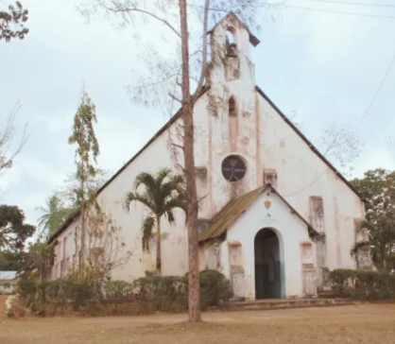
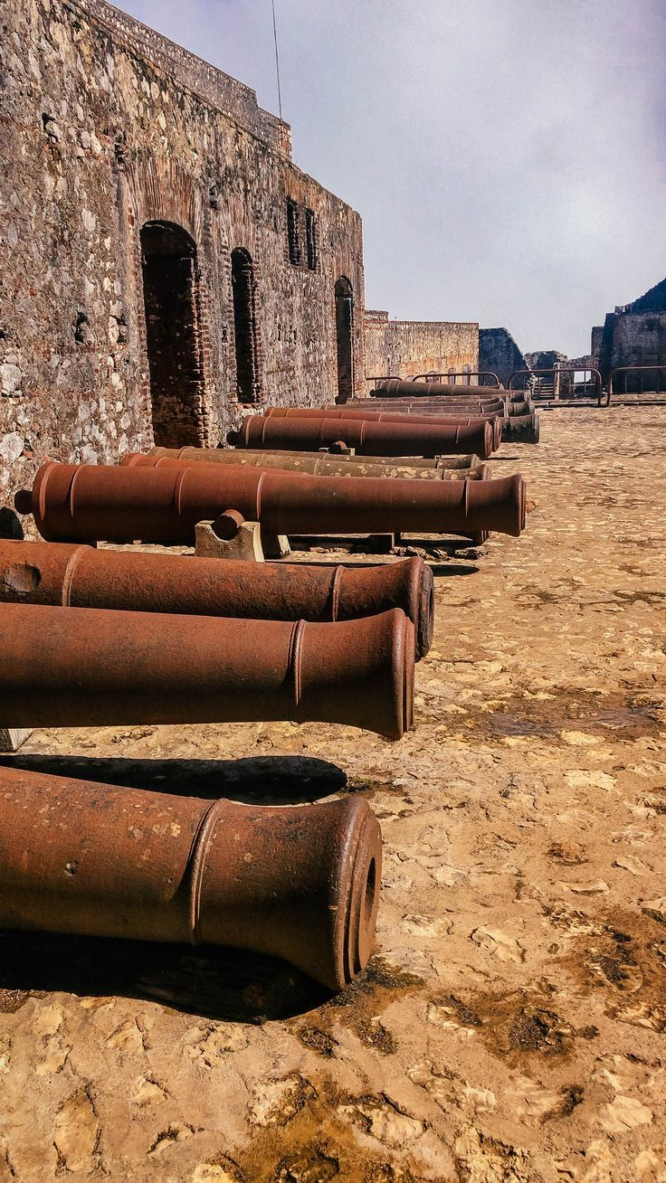
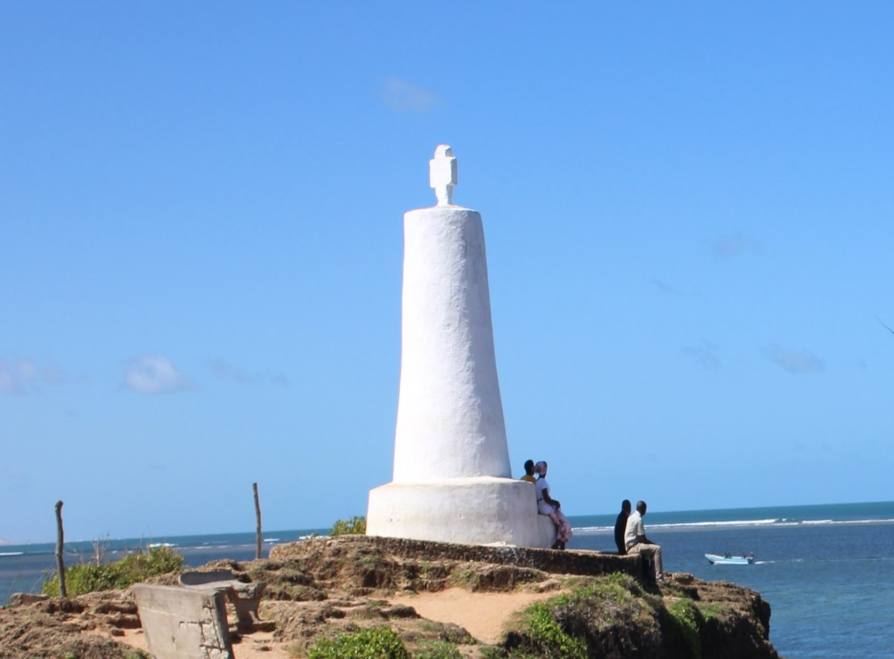
HISTORICAL BUILT IMAGES
THE RABAI MUSEUM
FORT JESUS
VASCO DA GAMA PILLAR

